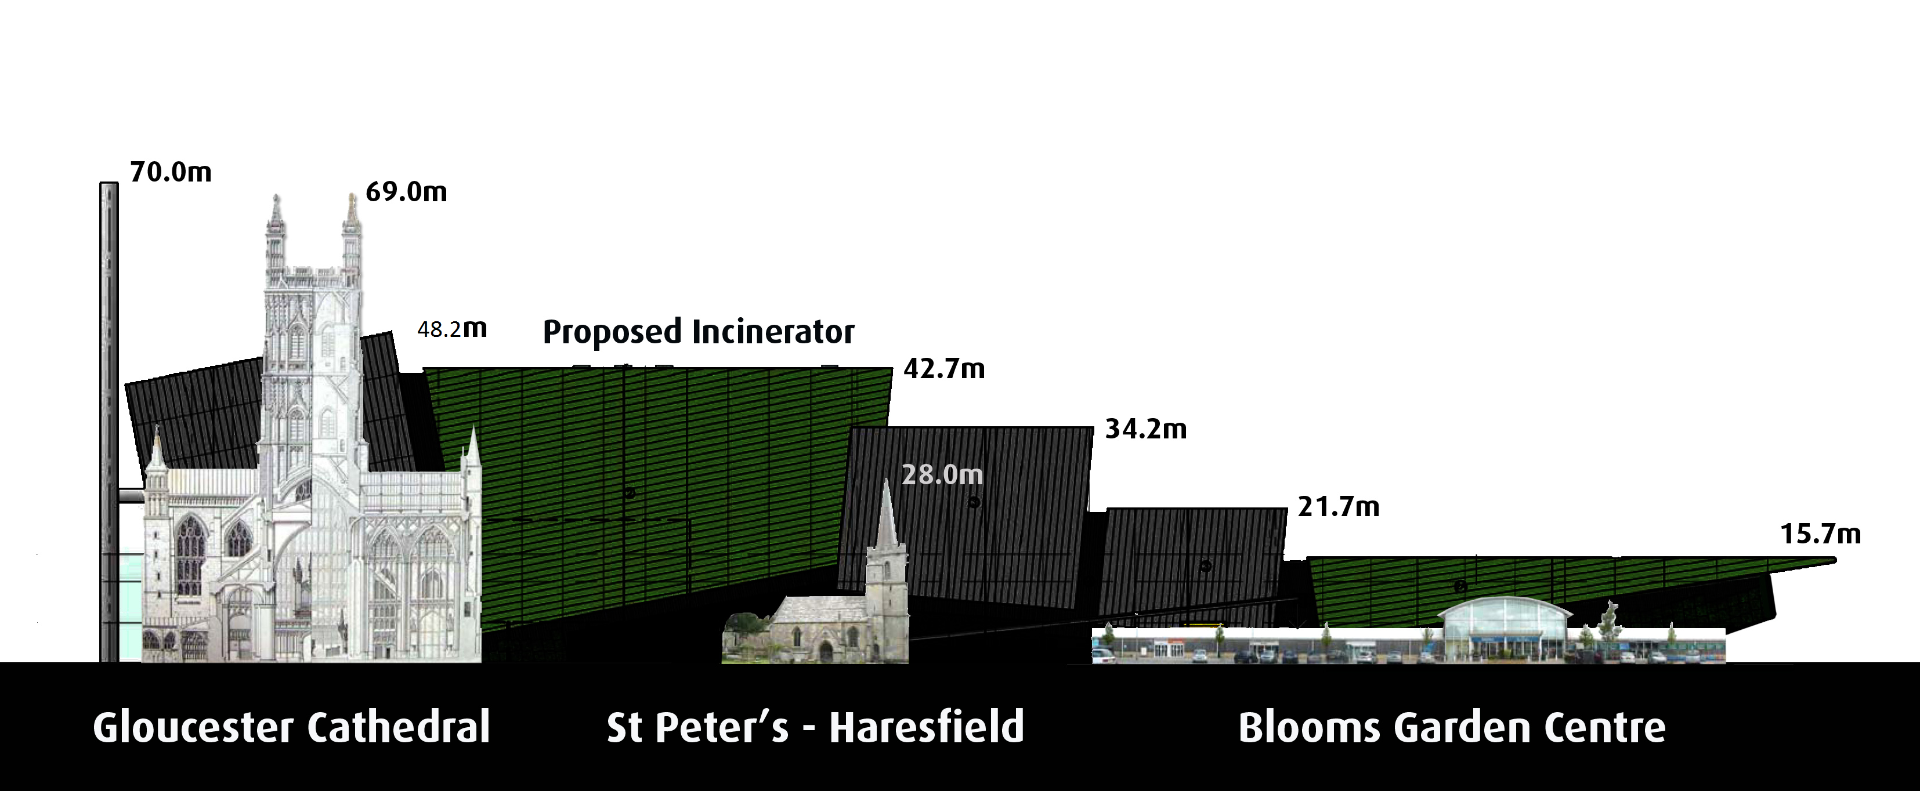

HUGE WASTE INCINERATOR planned
for JAVELIN PARK, near STONEHOUSE

SEE THE ACCURATE SCALED
VISUAL IMPACT
at the launch of a
DVD Presentation
and hear a talk about the impact of the incinerator on our health, the environment and the taxpayer

Thursday 13th September
at
The Old Town Hall Meeting Room,
The Shambles, Stroud
7.30 p.m. - 9.00 p.m.
(doors open at 7.10 p.m. for tea and coffee)

ADMISSION FREE
This Event is organised by: GlosVAIN www.glosVAIN.info
Scaled DVD produced by: Monostudio Ltd., Stroud, Tel. 01453 765366

